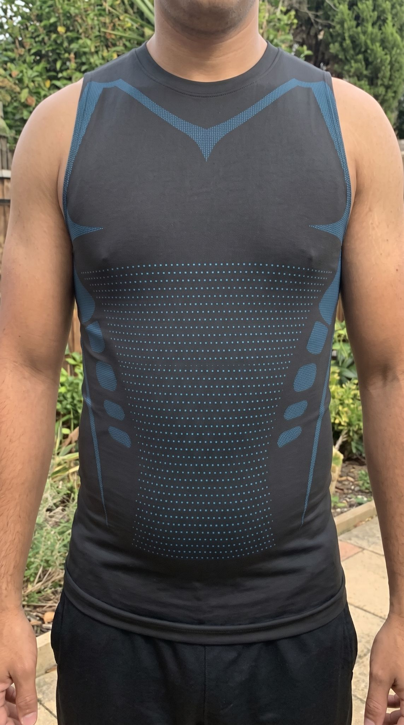
⭐⭐⭐⭐⭐ Does the job! Very satisfied "I was a bit hesitant before ordering, but the results are definitely there. The tank top sculpts the chest perfectly and instantly smooths out love handles. The compression is firm but the material stays super comfortable, even when worn all day under a t-shirt. Highly recommend!" — Laurent P.

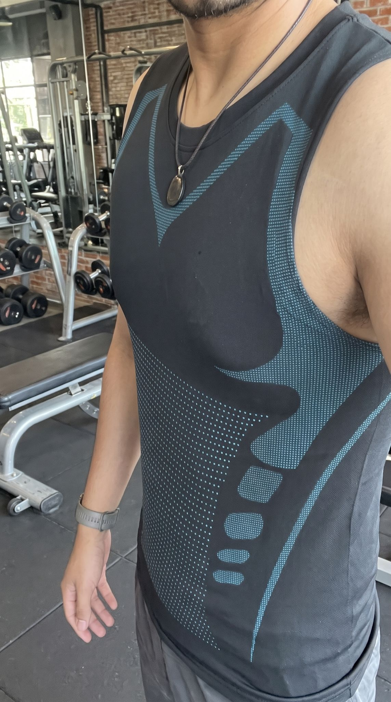
⭐⭐⭐⭐⭐ The absolute best for the gym "Tested it this morning at the gym and honestly, it's approved. The tank top offers great compression on the sides and really helps you feel supported when lifting weights. The fabric breathes super well, so you don't feel suffocated during the workout. Highly recommend!" — Maxime T.

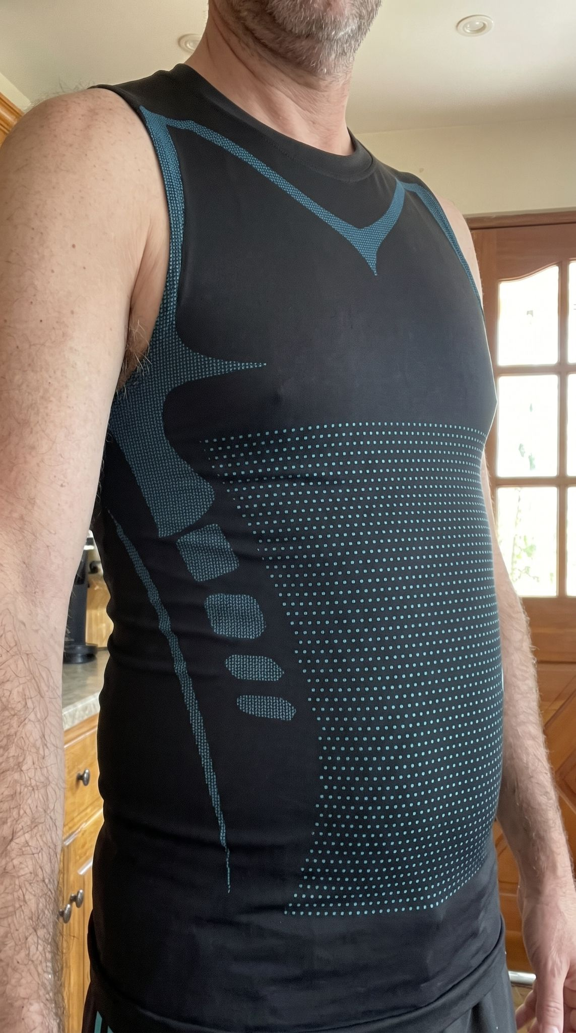
⭐⭐⭐⭐⭐ Great for smoothing the stomach "I don't spend my life at the gym; I was mainly looking for something to smooth out my stomach and love handles for everyday wear. The compression is super effective on the sides without restricting your breathing. I wear it all day long, even around the house, and it's very comfortable." — Stéphane R.

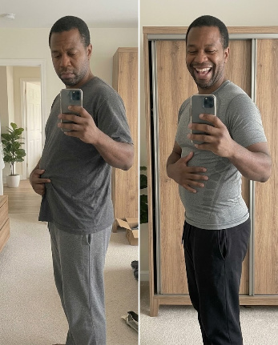
⭐⭐⭐⭐⭐ The picture speaks for itself! "I took a before and after picture to see if it actually worked, and the results are just mind-blowing. The shirt instantly smooths out the stomach and tucks everything in. Beyond the physical changes, it really brings back your smile and gives a massive boost to your self-confidence! I highly recommend it." — Fabrice C.

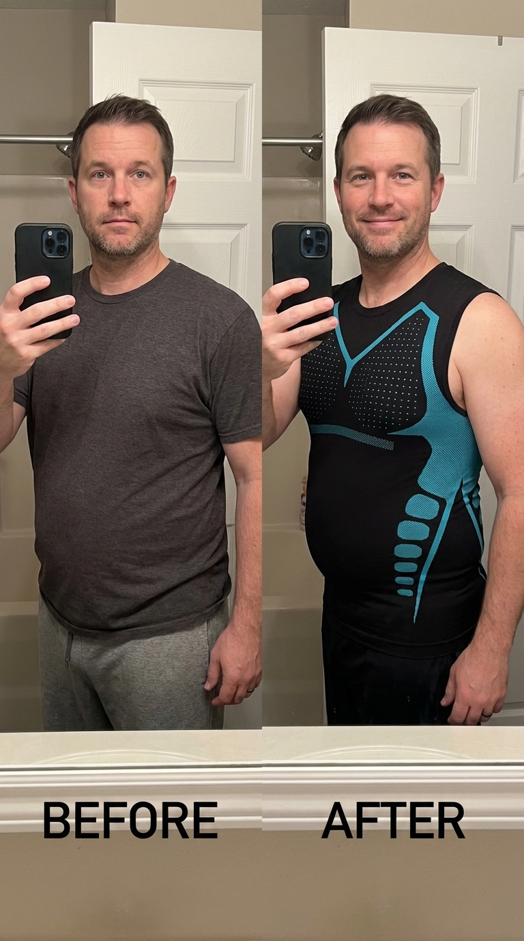
⭐⭐⭐⭐⭐ A complete game changer! "The 'before and after' really says it all. I used to wear baggy shirts because I was self-conscious about my belly. This compression top instantly smooths everything out and the blue bands actually help me stand straighter. It’s comfortable enough for everyday wear and the confidence boost is real—just look at my smile! Highly recommend." — Jason M.

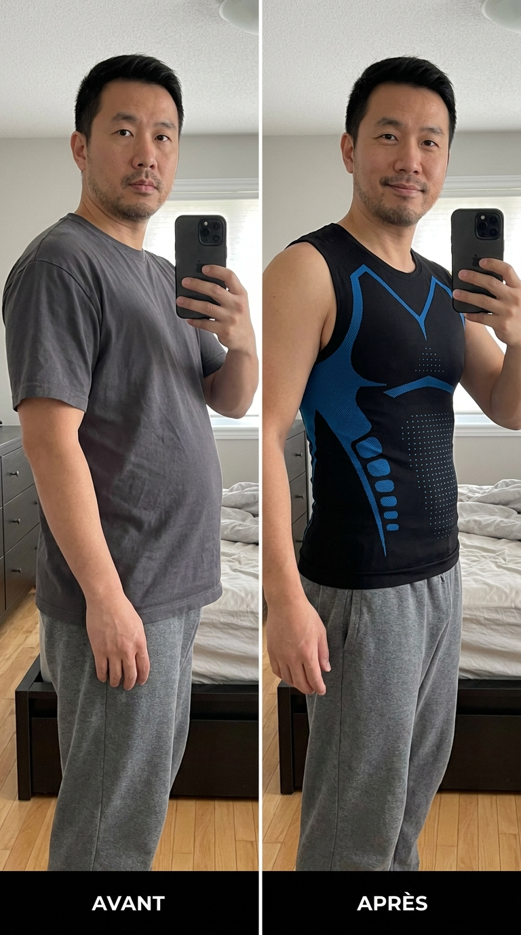
⭐⭐⭐⭐⭐ The side profile difference is huge! "The side-by-side picture speaks for itself. This tank top completely flattens my stomach and naturally pulls my shoulders back. I feel like a new man getting dressed in the morning. The support is firm but remains super comfortable all day." — Chen Z.

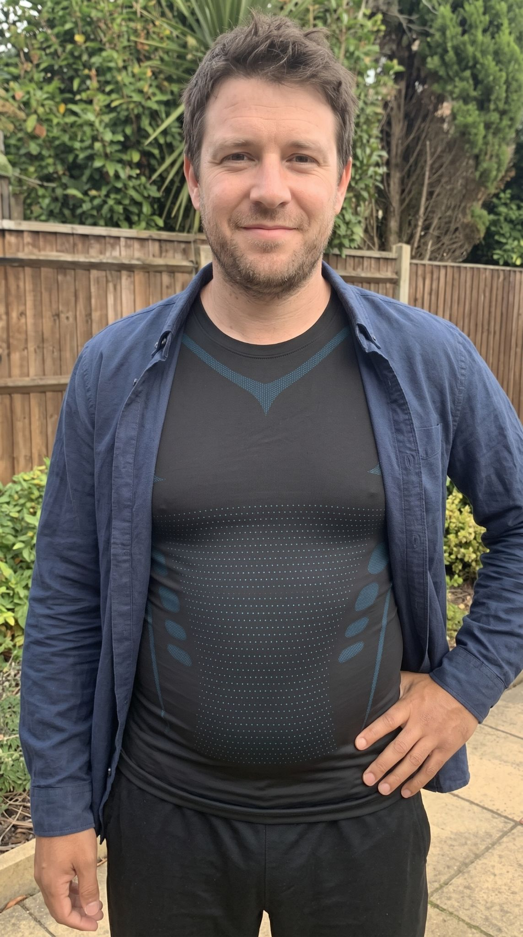
⭐⭐⭐⭐⭐ Looks great under a shirt! "I love the design of this tank top. Unlike other compression shirts that look like medical garments, this one looks awesome under an open button-down shirt. It perfectly flattens the stomach, doesn't roll up, and gives a real everyday confidence boost. I wear it all the time!" — Kevin L.

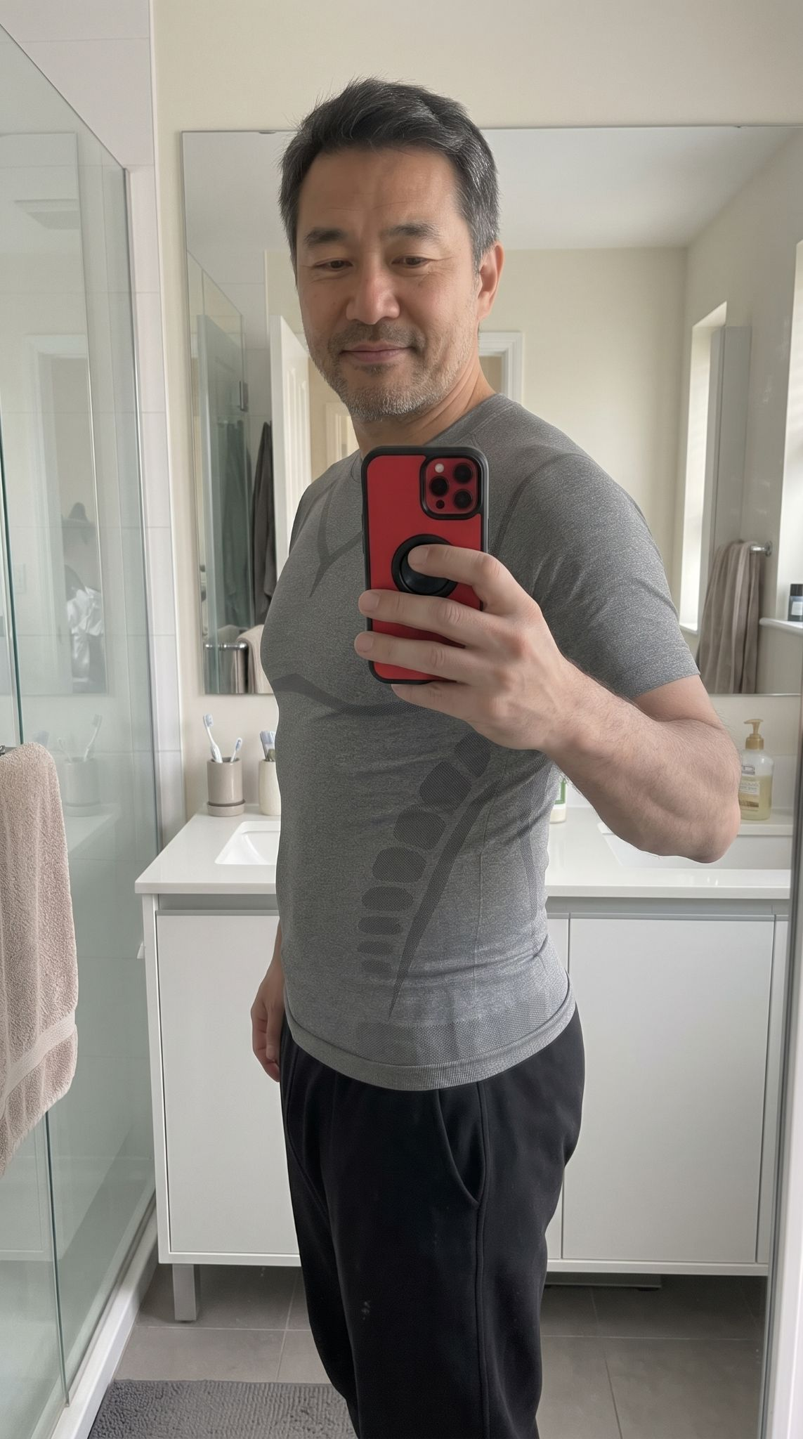
⭐⭐⭐⭐⭐ Perfect for everyday wear "I opted for the grey short-sleeve model and I'm thrilled with it. The compression bands on the sides do a great job of supporting my stomach and lower back. It's become my morning essential in the bathroom; it gives a great silhouette and stays very comfortable all day long." — Chen Z.

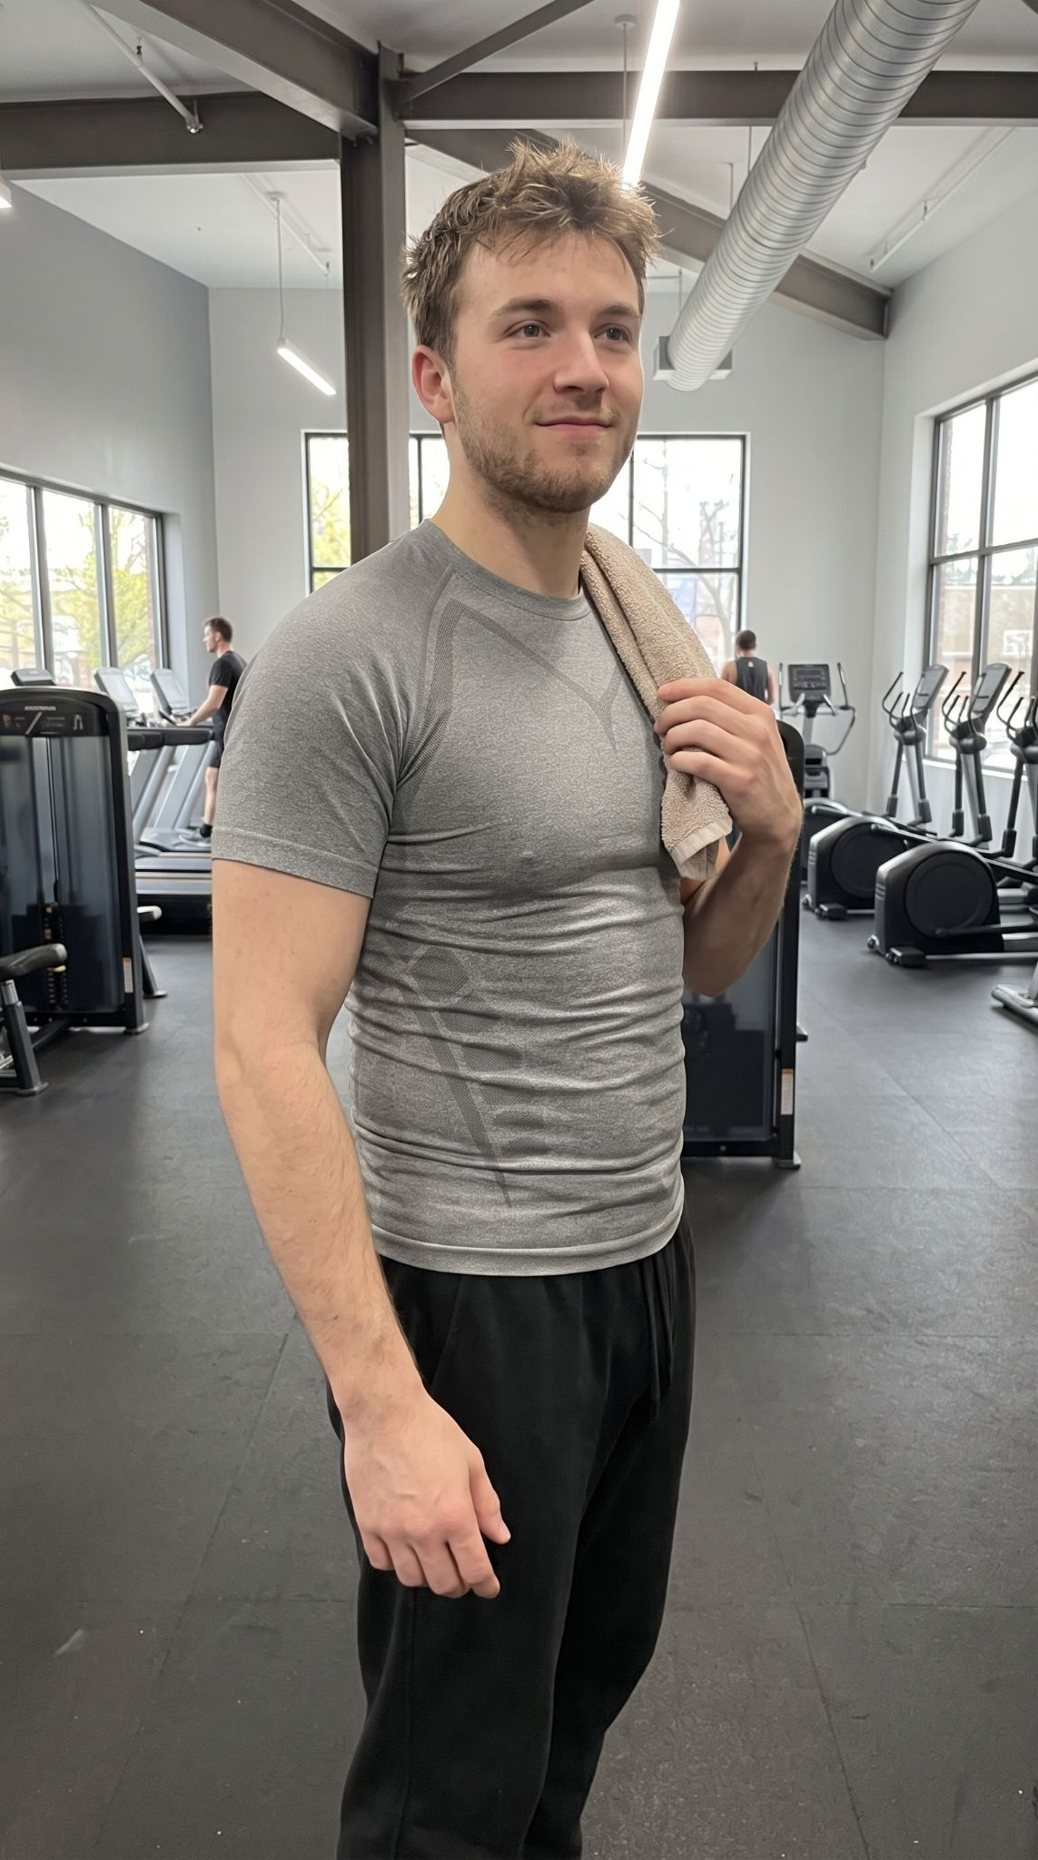

⭐⭐⭐⭐⭐ My new go-to gym shirt "I bought the grey short-sleeve version for my workouts and I'm honestly impressed. The targeted compression provides great support while lifting, and the fit really highlights the chest and shoulders. It's super breathable and wicks away sweat perfectly. Looks great and feels even better. Highly recommend for training!" — Alex M.

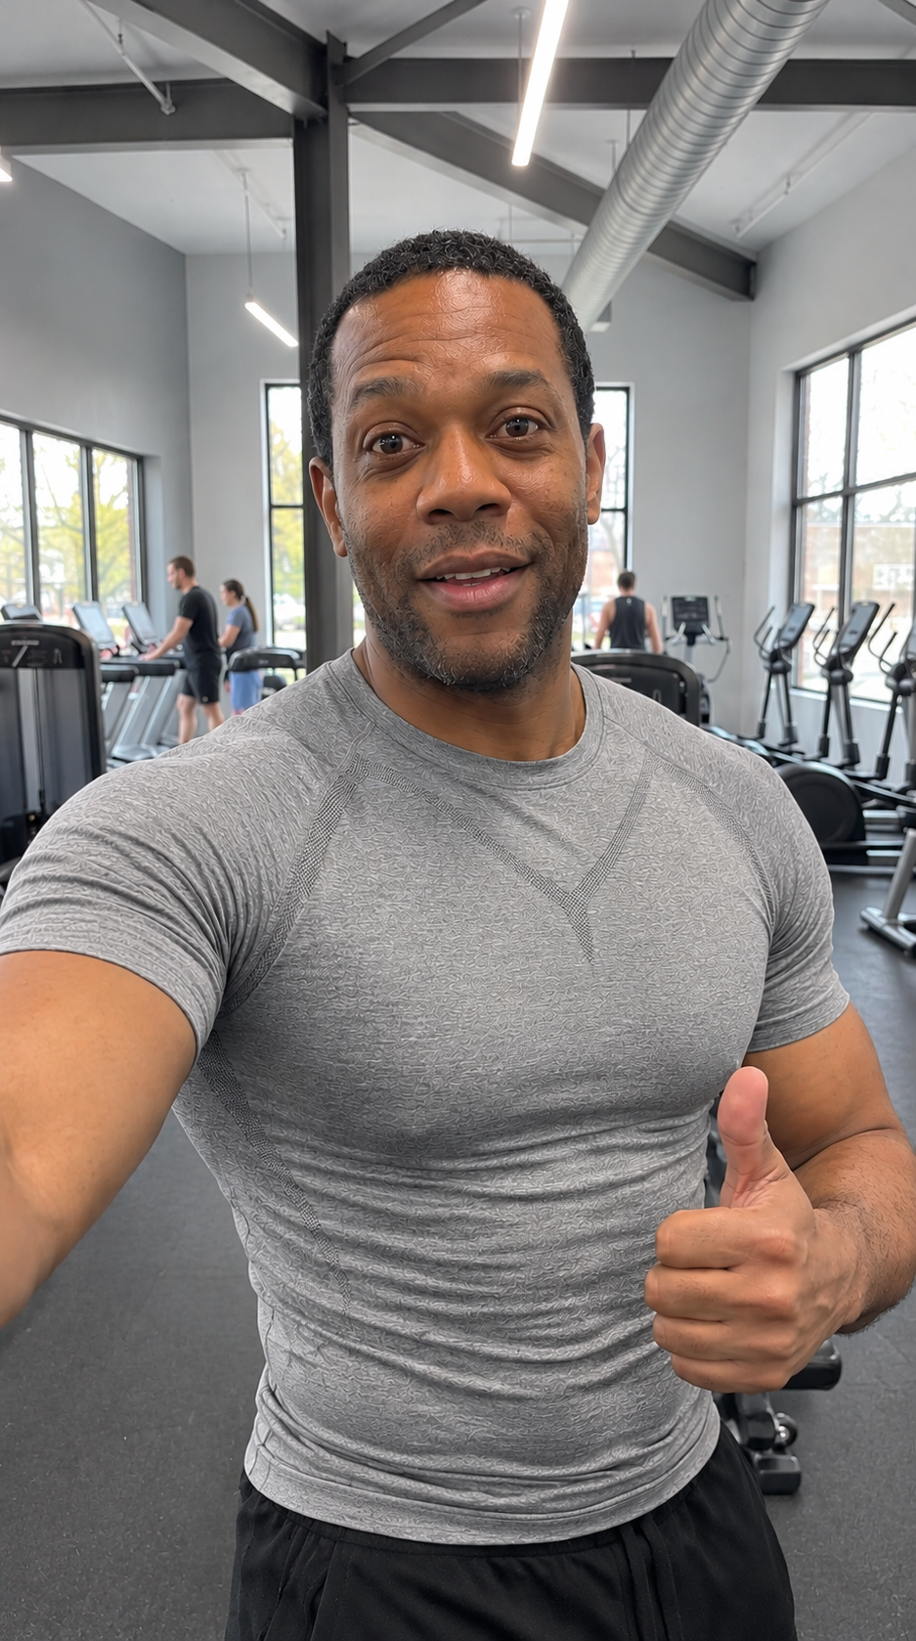
⭐⭐⭐⭐⭐ 100% gym approved! "Put this grey compression shirt to the test today at the gym and it gets a huge thumbs up from me. The fit is incredible—it really highlights your chest and shoulders while keeping your core perfectly supported. The material is super breathable even during an intense workout. Looks and feels amazing. Highly recommend!" — Marcus J.

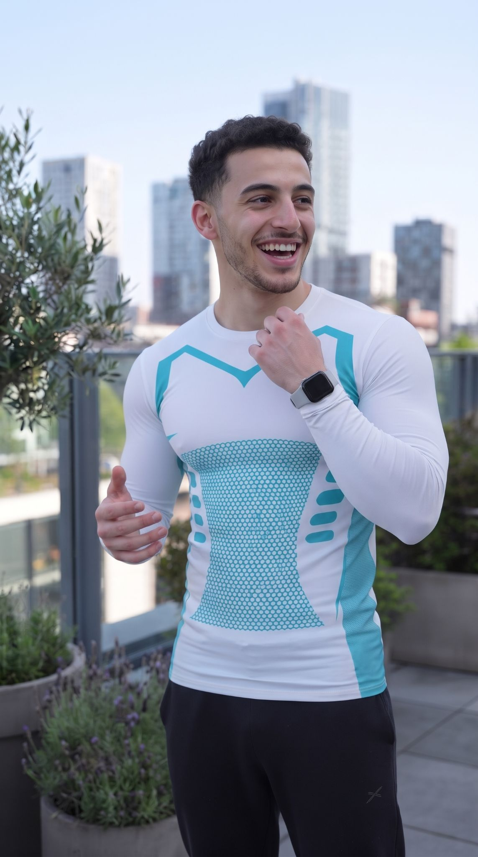
⭐⭐⭐⭐⭐ Awesome design and great fit! "I got the white long-sleeve version for my workouts and outdoor activities. The look is really modern with the cyan patterns; it doesn't look like typical shapewear at all. The fabric perfectly hugs the chest, highlights the shoulders, and gives a real confidence boost. I recommend it 100%." — Yanis M.

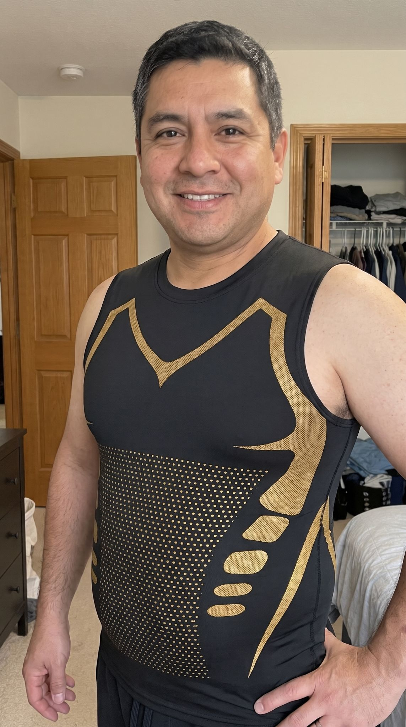

⭐⭐⭐⭐⭐ Great for everyday wear, highly recommend! "Ordered this compression top on a whim and I'm genuinely impressed with the results. It tightly compress everything around the waist without being too restrictive. Super comfortable, even for just wears around the house, and the gold accents give it an awesome style. Definitely visually reduces my belly. A solid buy!" — Carlos M.

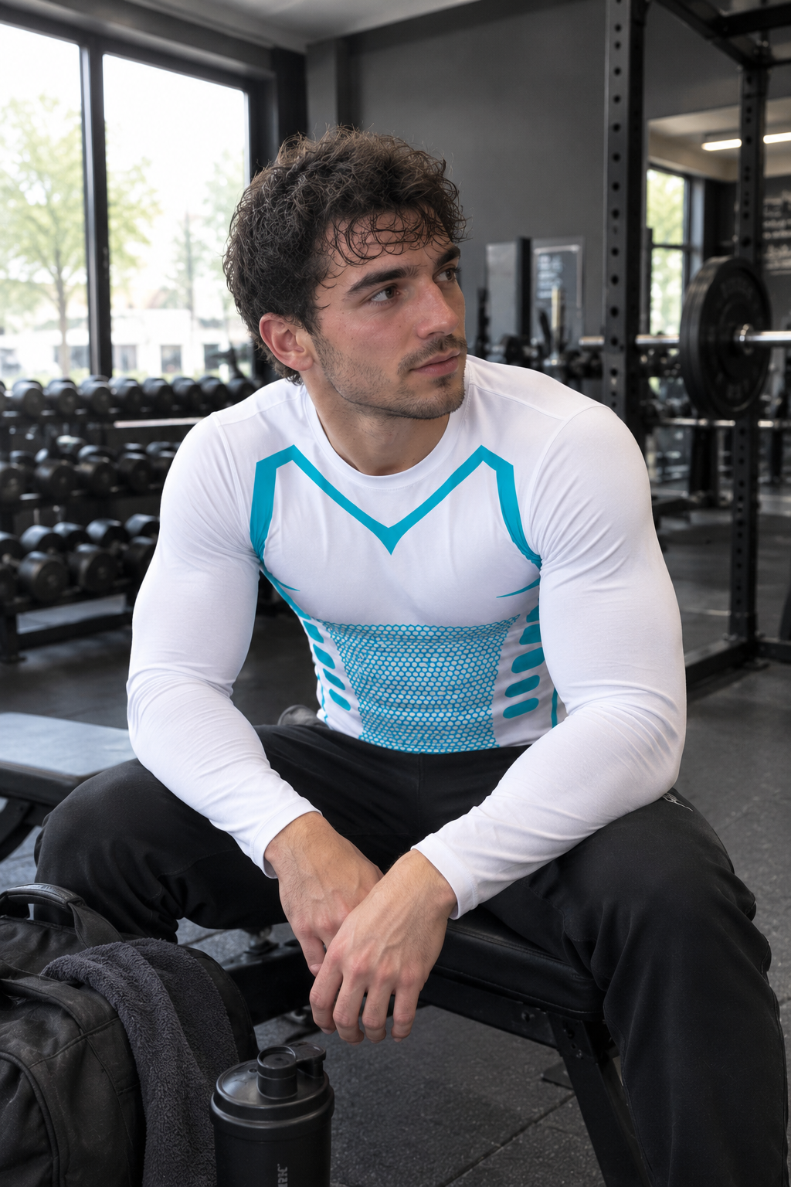
⭐⭐⭐⭐⭐ Hands down the best gym compression shirt I own! "I've been wearing the white long-sleeve version for my heavy lifting sessions, and it’s incredible. The support it gives my chest, shoulders, and back while sitting or moving is top-notch. It stays perfectly in place, doesn’t ride up, and the compression really helps with my posture and muscle fatigue. Plus, the white and cyan design looks absolutely fantastic and athletic. It's super breathable and handles sweat with ease. Highly recommend for anyone looking for serious workout support!"
— Jake M.

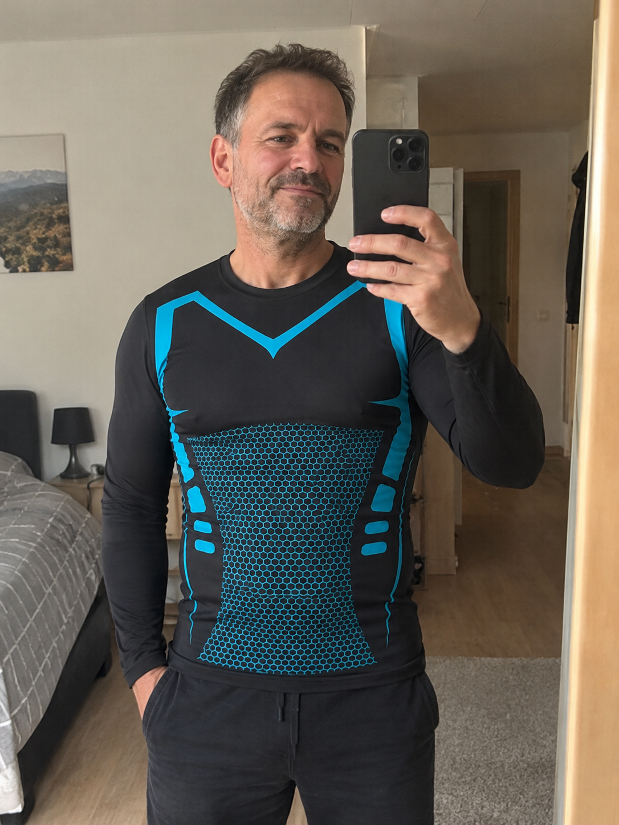
⭐⭐⭐⭐⭐ Great support and awesome design! "I tested this long-sleeve black and cyan model, and I'm really impressed. The compression is spot on: it provides great lower-back support, visibly slims the waistline, and gives an immediate sense of tone without ever restricting breathing. The fabric is very breathable, comfortable to wear during workouts or daily life, and the blue accents give it a truly dynamic look. A purchase I definitely don't regret!" — Marc D.

